**CEG4913 Weekly Progress Report**

Week #: 2

SCRUM/Sprint No. 10

Group Number: 3

Date: September 18th, 2025

One line summary of progress:

We have started the new part picking and ordering process, submitted our EEF form, and advanced our software work (UI/CAD).

# Work Completed

## Hardware:

* Updated our Jetson Nano drivers
* Submitted EEF form

## Software:

* Updated emergency contacts
  + Able to add multiple contacts and remove them as well

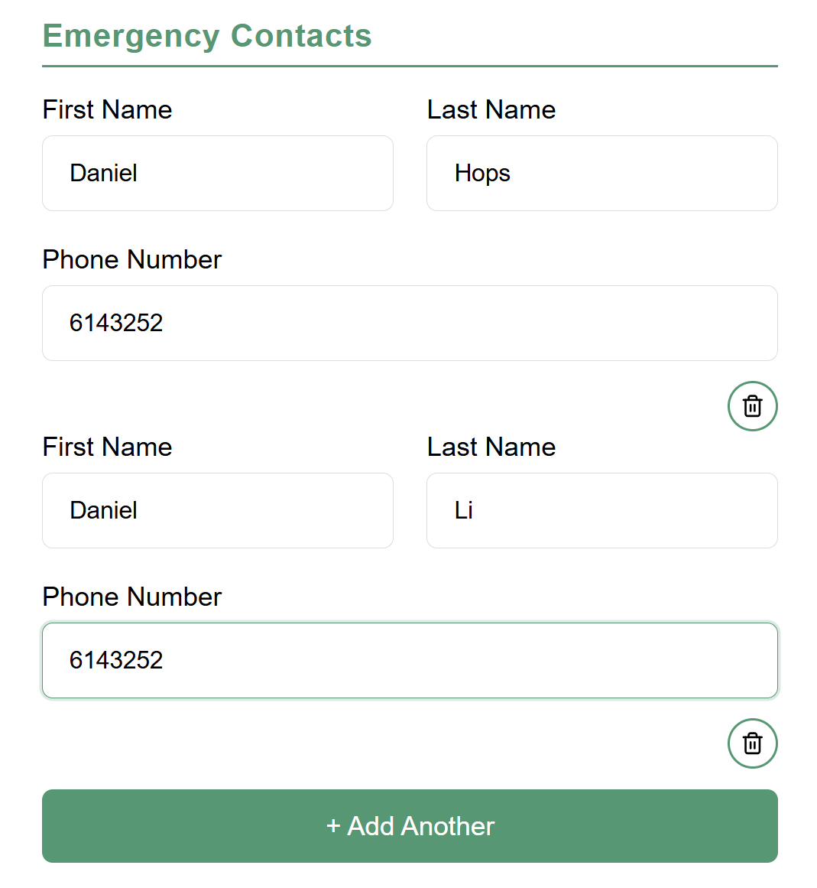

* Updated the screen UI Mockup



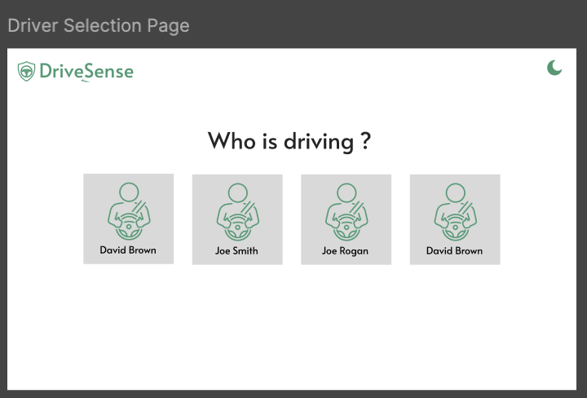

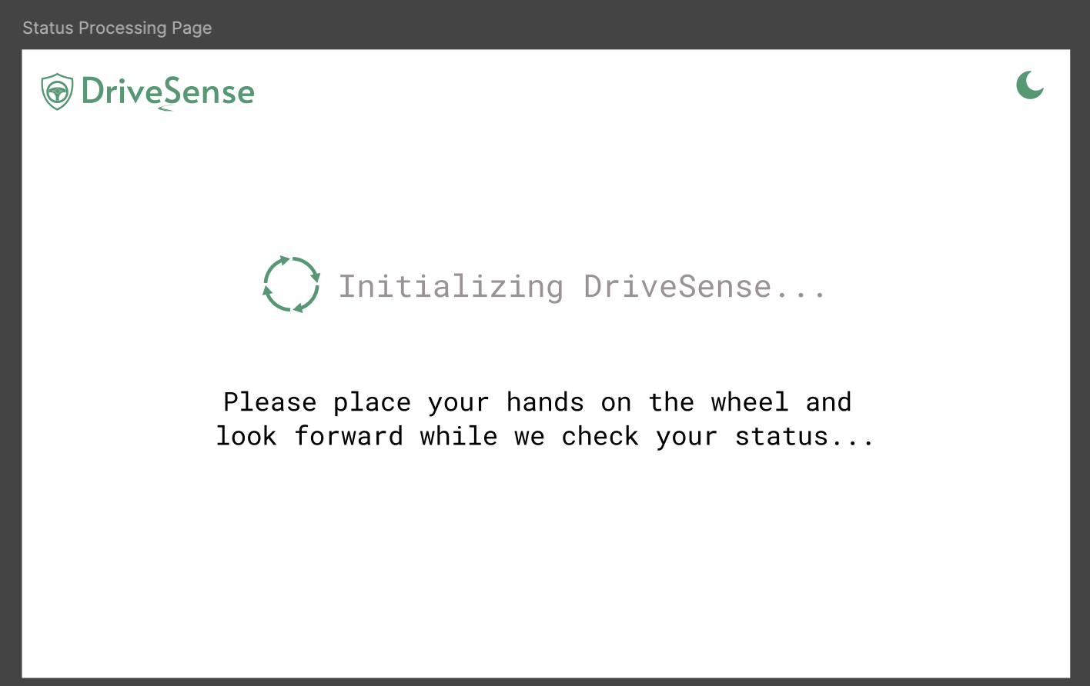

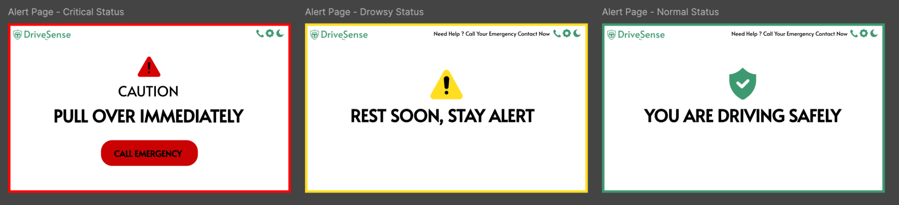

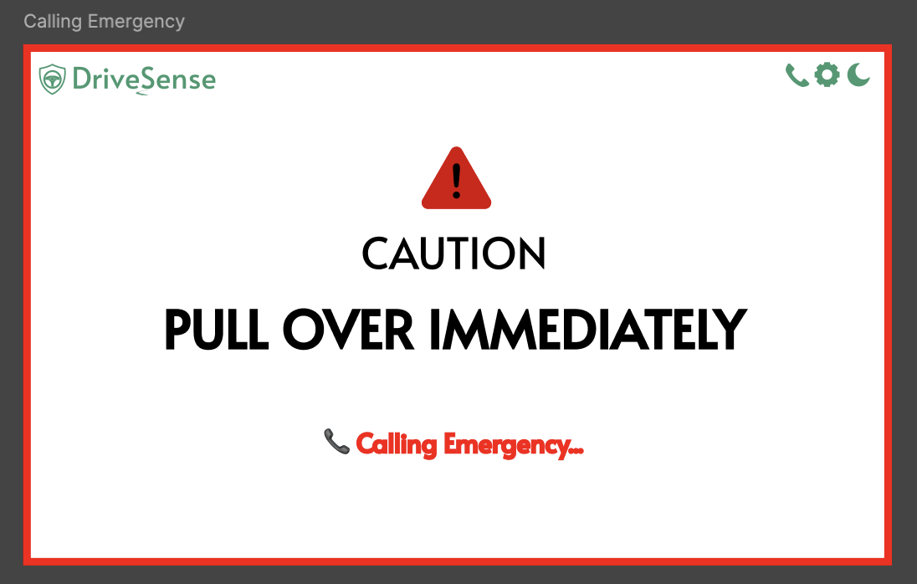

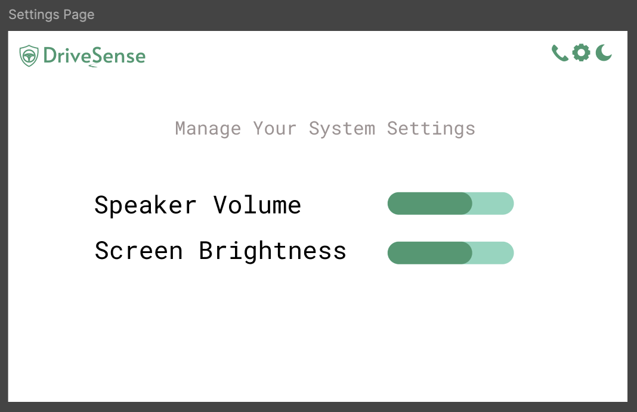

* Rewrote hardware sensor drivers in C++

## Team Member Contributions:

Aaditya Shah:

* Picked and ordered new parts for system

Abdullah Ramadan:

* Drafted CAD designs for new mounting design

Keith Tran:

* Updated JIRA board and workflow diagrams with latest tasks

Kevin Dang:

* Added additional functionality to website UI

Hajer Fguir:

* Developed new embedded UI for the application

Saurav Guduru:

* Dockerizing our development environment

## Issues and Resolutions:

Issue: None

Status: N/A

Resolution: N/A

# Plans for next week:

## Hardware Goals:

* 3D print initial prototype CAD designs

## Software Goals:

* Finish Screen UI Mockups
* Sketch initial new component mounts on CAD
* Dockerize our environment so we can work with a unified development environment
* Add notification when adding/removing a driver

## Management Board Screenshots:

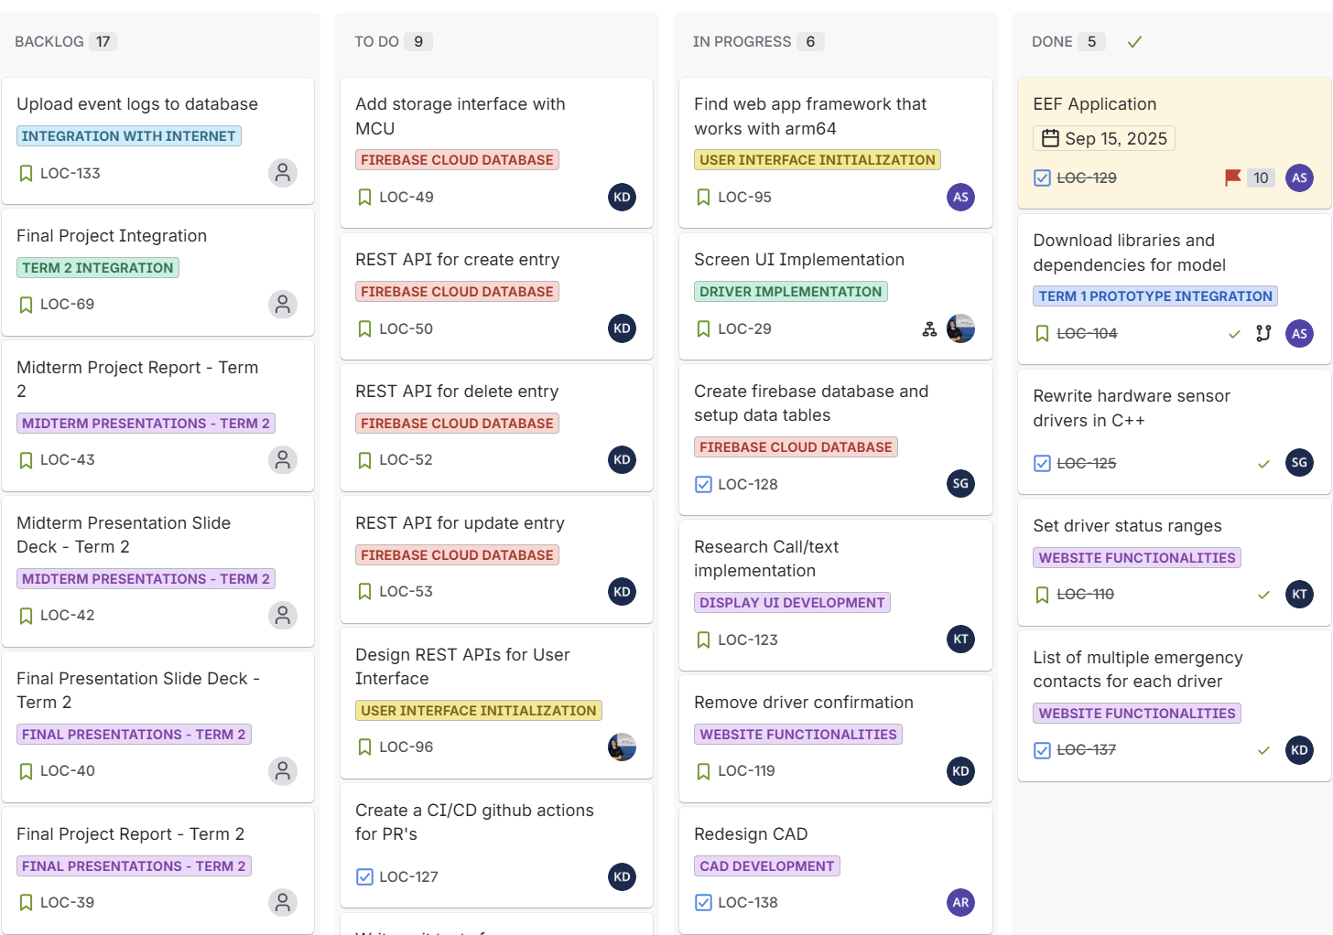

Figure 1 - General Management Board

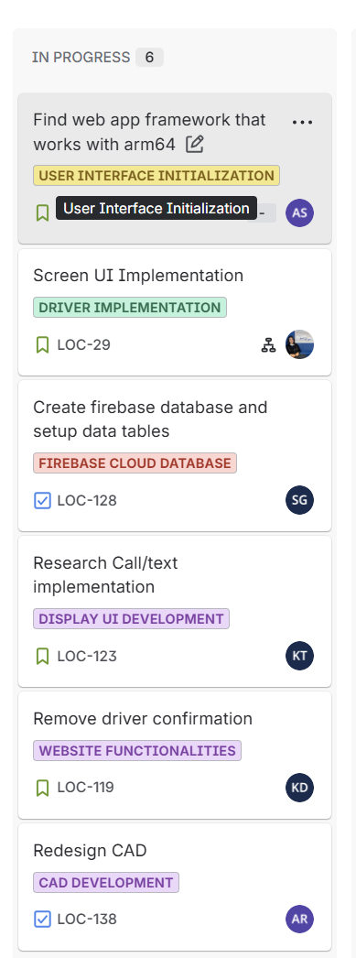

Figure 2 - This Week’s Sprint

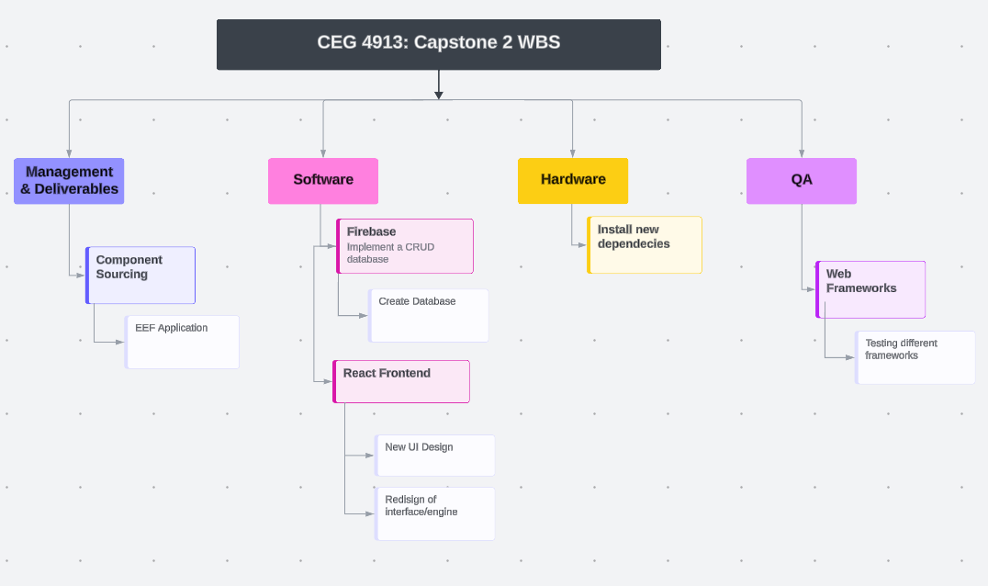

Figure 3 - WBS

## Additional Notes: